**Experiment 1**

# **Edge Detection Using Canny and Sobel**

Name: Akshat Pathak

Reg No.: 21BAI10053

# Canny

import cv2

from matplotlib import pyplot as plt

img = cv2.imread("C:/Python Program/Computer Vision//banana.jpeg")

edges = cv2.Canny(img,110,180)

cv2.imshow("orignal image",img)

cv2.imshow("Edges",edges)

cv2.waitKey(0)

cv2.destroyAllWindows()

# Output

 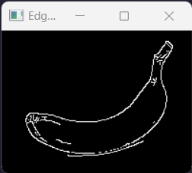

# Sobel

import cv2

from matplotlib import pyplot as plt

img = cv2.imread("C:/Python Program/Computer Vision//banana.jpeg")

edges = cv2.Sobel(img,-1,1,0)

cv2.imshow("orignal image",img)

cv2.imshow("Edges",edges)

cv2.waitKey(0)

cv2.destroyAllWindows()

# Output

 